PRPP Template Documentation

PRPP stands for Program/Resource Planning Process. It is the process through which each program/unit (aka Department) documents their progress/accomplishments in meeting the goals of the District and requests additional funding and resources to meet those goals. It is a yearly process. The information in the template rolls from year to year so each program/unit starts the year with the previous year’s information. The information can then be edited to suit the current year.

PRPP is comprised of various categories/sections that are displayed in the treeview at the left side of the screen. Clicking on a section brings up an edit window for maintaining the information in that section. There are two types of sections; text-sections and spreadsheet-sections. Text-sections have a document icon:  Spreadsheet-sections have a spreadsheet icon:  Text-sections can contain formatted text and graphics that are commonly pasted into the template from a Word document. Spreadsheet-sections contain information arranged in rows and columns similar to an Excel spreadsheet.

When entering the PRPP template you will be asked to log on using your normal email user/password. You will then be prompted to select a template. Your logon determines which templates you can edit or approve.

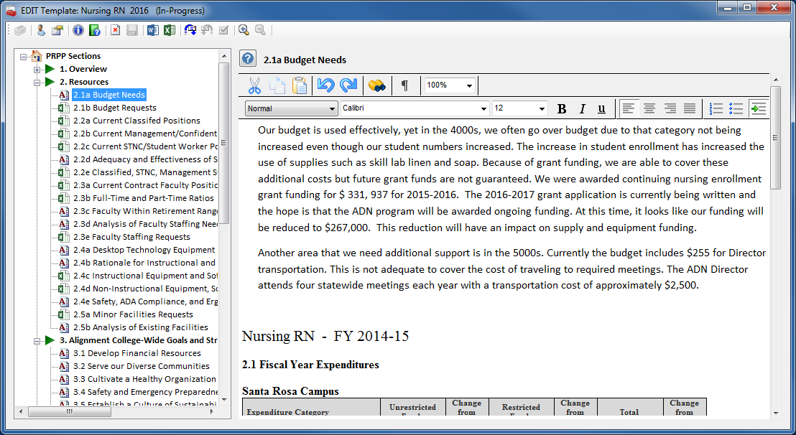

Editing Text Sections

Text sections are edited in the edit window on the right side of the screen. The edit window provides limited tools for formatting the text. Most people prefer to do their editing in Microsoft Word to take advantage of its advanced formatting features. The formatted text is then copy/pasted into the edit window. Graphics, such as charts and tables, can also be pasted into the edit window.

The Create Documents  function can be used to create a Word document containing the current contents of the template prior to editing.



Editing Spreadsheet Sections

Spreadsheet sections are edited in the grid on the right side of the screen. The information is entered directly into each cell, similar to editing an Excel spreadsheet. Dropdown menus are provided when choosing from a list of values. There is no need to save the changes when finished editing. Changes to the grid are automatically saved when the contents of the cell changes. Approvers, Deans, and VPs will see additional columns on the grid for their use that are not shown to the editors of the template. For example extra columns to rank requests at the cluster and VP level.

New rows are added by entering information into the blank row at the bottom of the grid.

Rows can be deleted by clicking in the gray cell at the left of each row and pressing the **Delete** button on the keyboard. A dialog box will be shown to confirm the deletion of the row.

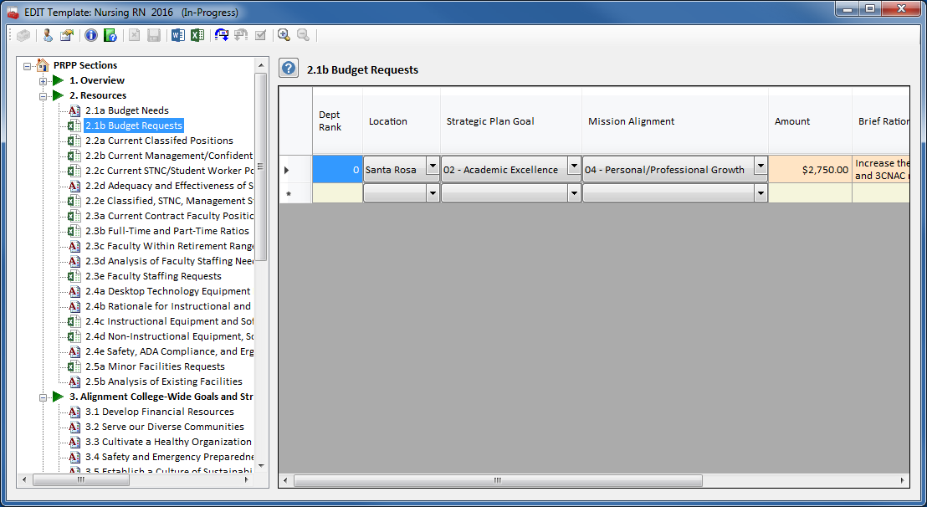

PRPP Toolbar Buttons

 **PRPP Administrator Tools** – used by PRPP Admins to maintain system-wide configuration information and pull District-wide master spreadsheets. These tools are documented in a separate document.

 **Logon** – logon as another user.

 **Select PRPP Template** – selects a PRPP template to view and/or edit.

 **View Template Information** – displays information about the template.

 **View PRPP Writer’s Guide** – displays the current PRPP Writer’s Guide document.

 **Clear Textbox** – clears all the text from the text-section edit window. Disabled when editing a spreadsheet-section.

 **Save Text Changes** – saves changes made to the text-section edit window. Disabled when editing a spreadsheet-section.

 **Create Documents** – saves the contents of the template as a Word document. Disabled if the user does not have a home directory.

 **Create Spreadsheets** – exports information from spreadsheet-sections. Saving the information is disabled if the user does not have a home directory.

 **Request Template Approval** – sends an email to the template approver requesting approval of the template.

 **Reject Template Approval** – sends an email back to the template editors explaining why the template wasn’t approved. Disabled if the user is not an approver.

 **FINAL Approval of Template** – approves the template. Once a template has been approved it can no longer be edited. PRPP Admins can re-open the template for editing on request. Disabled if the user is not an approver.

 **Increase Template Font Size** – increases the font size displayed in the treeview and spreadsheet-sections. This does not affect the font sizes of the text-sections.

 **Decrease Template Font Size** – decreases the font size displayed in the treeview and spreadsheet-sections. This does not affect the font sizes of the text-sections.

 **View Section Help** – displays help/instructions for the current section being edited. The help for each section is also found in the PRPP Writer’s Guide document.

 Logon

The Authenticate PRPP User Logon screen is the first screen displayed when getting in to PRPP. Logon with your normal District email user/password. Your logon determines which PRPP templates you can edit or approve.

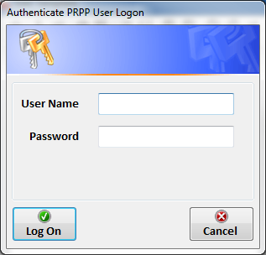

 Select PRPP Template

The Select PRPP Template screen is the second screen displayed when getting in to PRPP. Select the PRPP program/unit from the **Program/Unit** dropdown menu. You can limit the choices by selecting a component from the **Component** dropdown menu and/or selecting the Show ALL Program/Units or Show Program/Units I can EDIT options.

The PRPP templates for the selected program/unit will be displayed. Approved templates from previous years are shown with a green checkmark icon:  The current in-progress template is shown with a yellow exclamation-point icon:  Select the template you want to view or edit and click the **OK** button.

Approved templates become public documents and can be viewed by anyone. In-progress templates can only be opened by the editors and approvers of the template. An error message will be displayed if you attempt to open a template you’re not authorized to access.

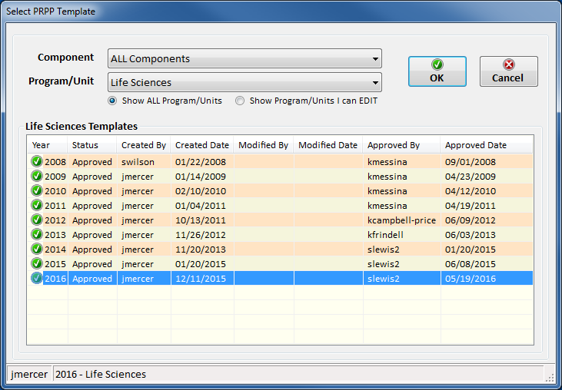

 View Template Information

Displays information about the currently selected PRPP template and the logon user. Shows the status of the template, the current editors and approvers of the template, and the user’s level of access to the template.

Note: PRPP saves documents and spreadsheets in the user’s home directory, usually referred to as the “X” drive. The create documents and save spreadsheets buttons will be disabled if the user does not have a home directory. Home directories are created by Information Technology while creating the user account. Contact the Help Desk for additional information.

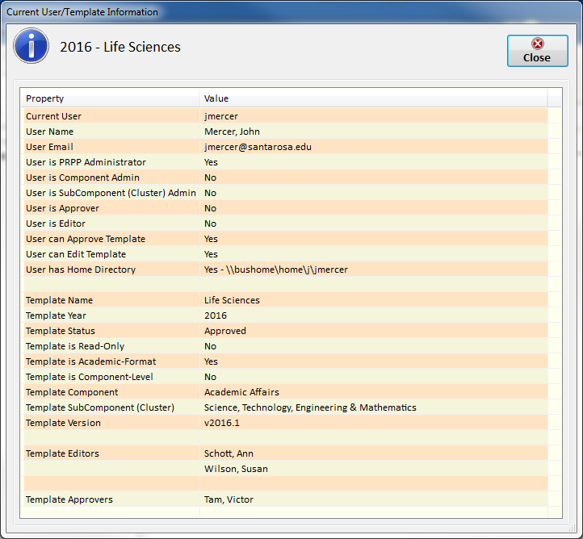

 View PRPP Writer’s Guide

Displays the complete text from the current PRPP Writer’s Guide document.

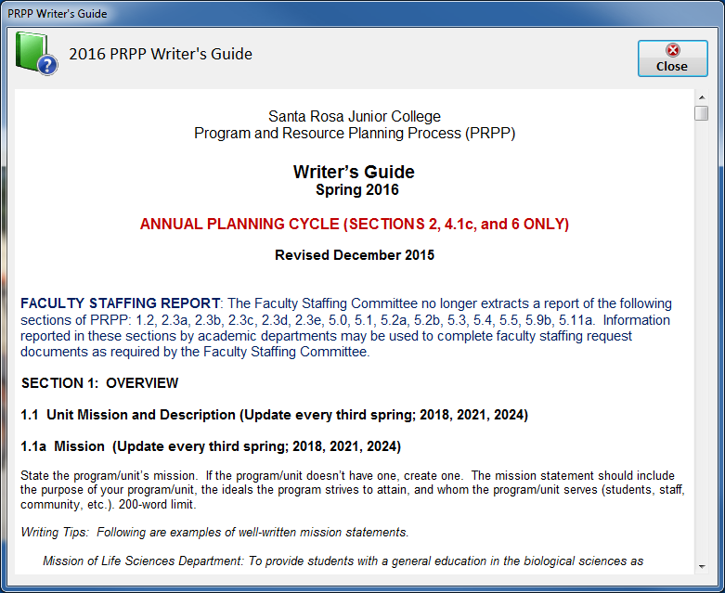

 Create Documents

Creates a document containing the contents of the currently selected PRPP template. Select the type of document from the **Document Type** dropdown menu and click the **Create Document** button. The document types are:

**Complete PRPP Template**

**Faculty Staffing Requests Sections**

**Strategic Planning Sections**

**Annual Planning Sections**

The default is to create a Word document. You can choose to create a pdf document instead. The document will be saved in the user’s home directory.

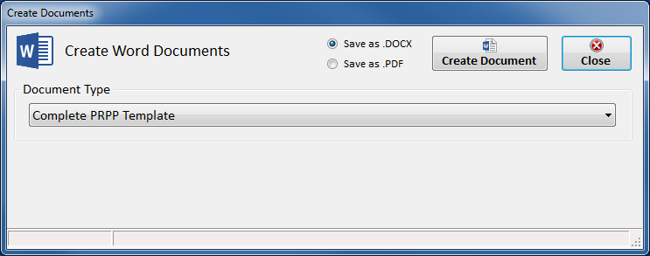

 Create Spreadsheets

The Export Spreadsheet Data screen serves multiple purposes. Its primary purpose is to harvest data from the spreadsheet-sections of PRPP and export that data as a spreadsheet file. It also serves as a way for the cluster Deans and the VPs to rank all the requests in their cluster or component. Approvers, Deans, and VPs will see additional columns on the spreadsheet for this purpose that are not shown to the editors of the template.

The Export Spreadsheet Data screen has its own set of toolbar buttons:

 **Select Records** – displays the Select Records screen to select the spreadsheet data to harvest.

 **Create CSV File** – saves the selected records as a csv spreadsheet file. The file will be saved in the user’s home directory. Disabled if the user does not have a home directory.

 **Cut** – disabled.

 **Copy** – disabled.

 **Paste** – disabled.

 **Enable/Disable Editing** – enables or disables editing of the data. Editing must be enabled before the Deans or VPs can rank the requests.

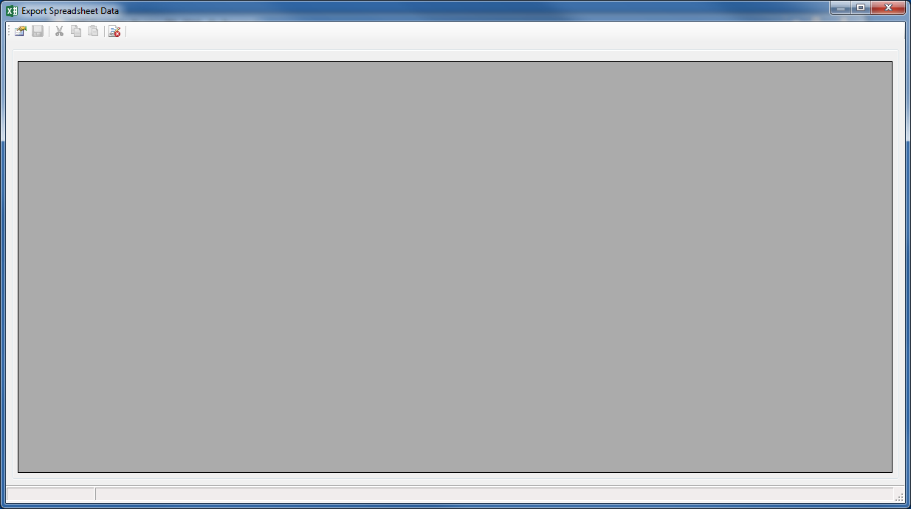

Select Records

The Select Records screen is used to select the spreadsheet data to harvest. Select the PRPP spreadsheet-section to harvest from the **PRPP Section** dropdown menu. The selection can be narrowed down by selecting values from the **Year**, **Template Status**, **Location**, **Strategic Plan Goals**, and **Mission Alignment** dropdown menus.

Users who are Cluster Admins or Component Admins (Deans and VPs) can use the **Component**, **SubComponent**, and **Program/Unit** dropdown menus to select records from all the program/units in their cluster or component. These records can then be edited and ranked as a group.

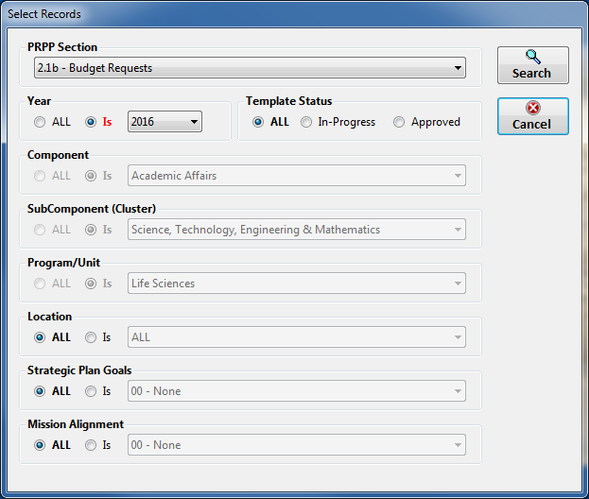

Export Spreadsheet Data

The selected records will be displayed in the grid. If editing has been enabled the data can be edited or ranked. New records cannot be added in this screen.

Individual columns can be hidden by right-clicking the column header and selecting the **Hide Column** option. Hidden columns will not be included when the data is saved as a spreadsheet file. The hidden columns will be restored when the records are re-selected on the Select Records screen.

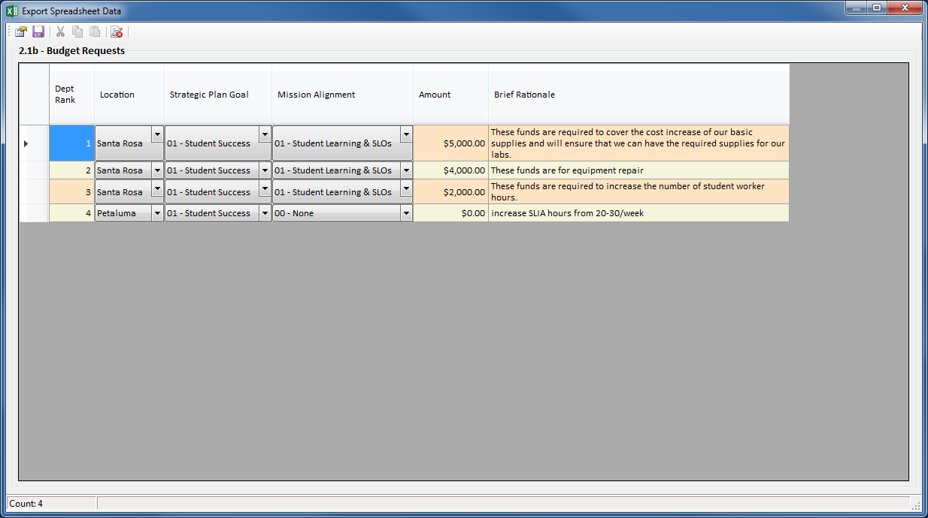

 Request Template Approval

Sends an email to the approver requesting FINAL approval of the PRPP template.

There is no chain of command in the approval process. There is only one final approval of the template. PRPP is a collaborative process. Everyone on the editor list is considered equal, any one of them can request approval of the template. Usually the highest ranking editor (Dean, department chair, director, etc.) is designated as the one to submit the template for approval. When the editors reach consensus and complete the template, that person submits it for approval.

The Subject and Message can be edited to send additional information to the approver.

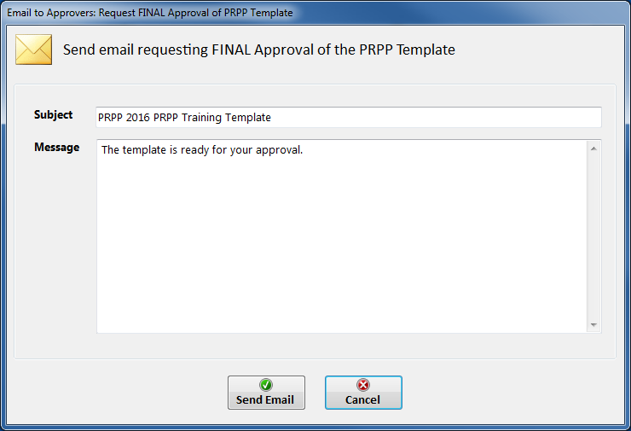

 Reject Template Approval

Sends an email back to the editors rejecting their request to approve the PRPP template.

If the approver feels the template needs additional work, he/she can reject the request for approval and send the template back to the editors with instructions on what needs to be improved. The editors will then revise the template and resubmit it for approval.

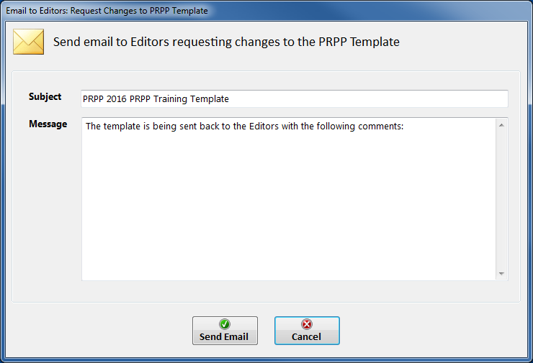

 Final Approval of Template

Sends an email to the editors notifying them that the PRPP template has been approved.

Once a template has been approved it can no longer be edited. PRPP Admins can re-open the template for editing on request.

